Tasting notes
Yarmouth Barbers & Connoisseurs

Contents
- Sparkling
  - Champagne
  - Rosé
- White
  - French
  - Spanish
  - Italian
  - German
  - Hungarian
  - New world
- Rosé
  - French
- Red
  - French
  - Spanish
  - Italian
  - New world
- Sweet Wine
- Port

- Sherry

- After Dinner
- Whisky
- Bourbon & Rye
- Rum
- Gin
- Vodka
- Tequila
- Cocktail & Mixers
- Cigars

Billecart Salmon Brut Reserve

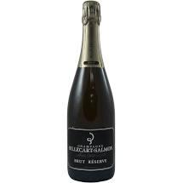

Grape: Pinot Noir, Chardonnay and Pinot Meunier.

Region: Champagne.

Tasting notes: Straw yellow in colour with an abounding mousse, the nose is soft and broad with fresh apple and pear notes together with fresh floral overtones and subtle suggestions of hazelnuts. Flavoursome and impeccably balanced in the mouth, citrus and orchard notes are integrated with suggestions of bread and honey. Crunchy and long on the finish.

Pairing: It is perfect as an aperitif and can be enjoyed with a wide variety of dishes. Should be served at 8 degrees.

£82 per bottle.

2013 Nyetimber Tillington Single Vineyard
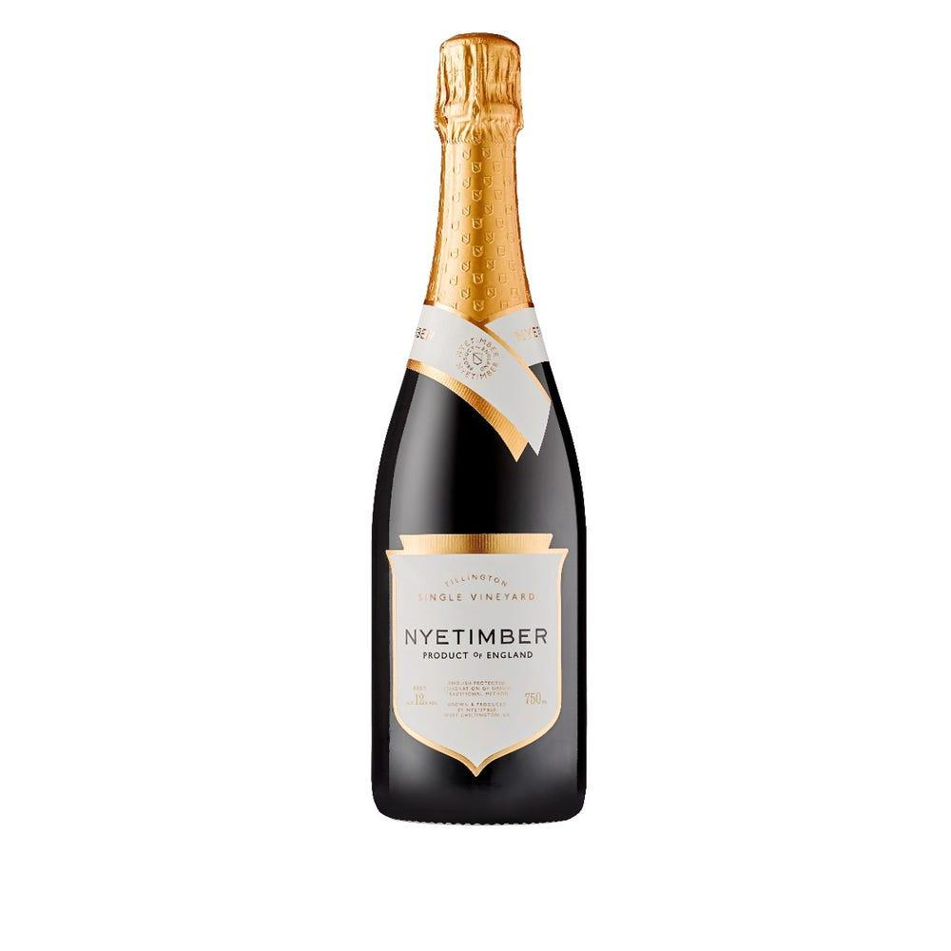

Grapes: Pinot Noir, Chardonnay

Region: West Sussex

Tasting notes: As the fine bubbles rise to the top of this pale gold wine, aromas of wild strawberries and raspberries emerge, and are reminiscent of British summer fruits. On the palate this delicate fruit is accompanied by complex flavours of toasted almonds, pastry, and praline. The wine balances elegance and richness in perfect harmony, with a refreshing acidity and a textured, decadent finish.

Pairing: Pairs well with Monkfish, Lobster, Turbot & Chicken.

£110 Per Bottle.

2006 Charles Heidsieck Blanc de Millenaires

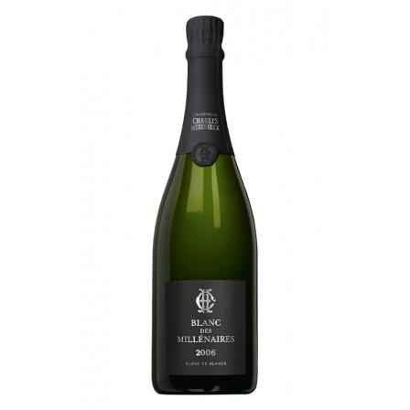
Grape: Chardonnay

Region: Champagne

Tasting notes: To the eye, a deep golden hue with glints of light green. Floral notes of violets and acacia on the nose, leading into deeper notes of blood orange and a hint of Mediterranean maquis. When swirled, fruity notes of pineapple, apricot, fig, and date appear with a pronounced intensity. On the palate, the remarkable signature texture of Blanc des Millenaires is revealed. Beginning with a saline and chalky texture, the palate moves into creamy notes of nougat, citrus, and whipped cream. A round and generous finish which almost glows with toasted accents.

Pairing: Pairs well with pork, rich fish, shellfish, and mild & soft cheese.

£165 per bottle.

2010 Dom Perignon Brut
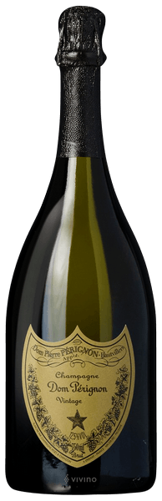

Grape: Chardonnay & Pinot Noir.

Region: Champagne.

Tasting notes: On the nose, there is luminous sweetness of tropical fruit – green mango, melon, pineapple – it instantly shines. It then cedes to more temperate notes, the tingle of orange zest, the mist of a mandarin orange. The wine breathes, revealing its freshness. The bloom after the rain. A tactile sensation of peony, jasmine and lilac. On the palate, it immediately imposes its ample presence, full and massive. A sappy sensation dominates as the tactile is rapidly overtaken by the aromatic. The body unfolds: generous, firm and controlled. Then it contracts, letting the wine vibrate with spices and pepper. The energy is sustained to a scintillating, saline finish.

Pairing: Best paired with crispy foods that are high in fat content. Since it is known that champagne is best served with savoury foods, the Dom Perignon is also best with heavily seasoned meals. The citrus content of the Dom Perignon cuts through the dish and makes it lighter on the palate.

£165 per bottle.
Gosset Grand Rose Brut

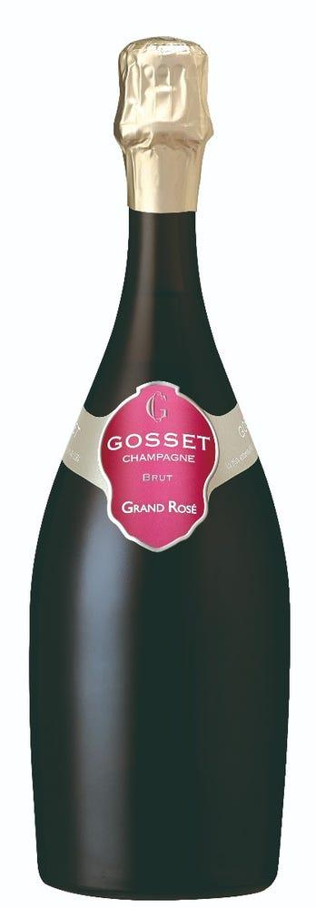

Grapes: Chardonnay, Pinot Meunier, Pinot Noir.

Region: Champagne.

Tasting Notes: An attractive bouquet of sweet red apples, fresh pastry and orange rind. On the palate, the wine is medium to full-bodied, concentrated and powerful, built around a bright spine of acidity. Pure, light, highly elegant, round and intense, this is a picture-book Champagne of great finesse and delicacy. The persistent finish is lovely, pure and extremely stimulating in its salty/mineral freshness; whereas the fruit is articulated in an aristocratic reticence and perfectly integrated into the noble, overall expression.

Pairing: Performs well as an aperitif & matches foods such as saltwater fish, small game and fruit desserts.

£71 per bottle.

Ruinart Rosé Champagne
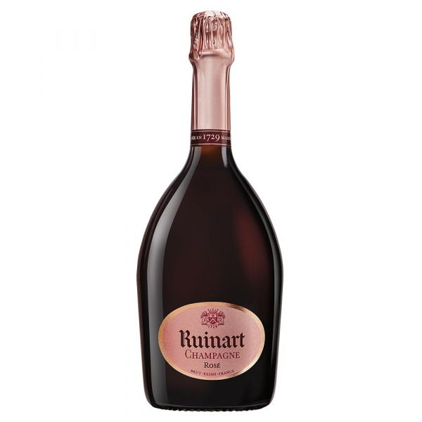
Grape: Pinot noir & Chardonnay.

Region: Champagne.

Tasting notes: The colour is a delicate pomegranate pink with very slightly orange reflections. The sparkling, light effervescence has a persistent foam. The nose is subtle and fresh, first offering an original palette of tropical fruits (guava and lychee) and small berries (raspberries, cherries and wild strawberries) in the first instance. These are followed by rose and pomegranate notes which complete the complex, intense aromatic profile, dominated by somewhat undeveloped primary aromas. On the palate the attack is distinct and full, cradled by a gentle effervescence. The aromas of freshly picked berries are fully expressed. The balance brings together a delightful freshness and voluptuous body, expressed by an elegant bracing touch of mint and pink grapefruit.

Pairing: It will be enhanced by thin slices of fine Italian prosciutto (San Daniele, Parma, etc.). A starter of mi-cuit salmon, or salmon prepared as a Japanese “tataki”, will reveal its many facets. For a main course, it will be a remarkable complement to a leg of milk-fed lamb or a low temperature cooked veal fillet. At the end of the meal, it will find its full expression with a berry soup enhanced with an excellent Modena balsamic vinegar.

£90 per bottle.

Billecart-Salmon Brut Rose
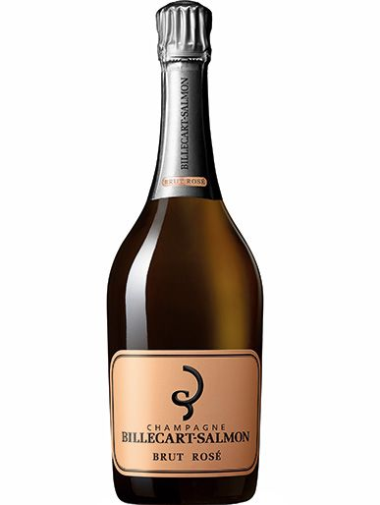

Grapes: Chardonnay, Pinot Meunier, Pinot Noir.

Region: Champagne.

Tasting notes: Pale pink in colour with steady fine bubbles, the nose is fine and elegant with soft strawberry and raspberry notes set against savoury, bread and biscuit undertones. Refined and delicate in the mouth, red fruit flavours come to the fore, accentuated by fresh acidity and beautifully balanced bubbles.

Pairing: This wonderful wine would serve as an aperitif option, or alternatively would pair well with salmon and sushi dishes.
£93 Per Bottle

2019 Pouilly Fume Domaine de Bel Air 'Cuvee des Acoins'

Grape: Sauvignon Blanc.

Region: Loire.

Tasting notes: Well-balanced and rounded, this wine delights with its fruity and mineral flavour profile. The lees character adds complexity and texture on the mid-palate. It displays excellent tension through to the finish, which is long and has a subtle spiced, flinty-ginger kick.

Pairing: Ideal partner to fish, shellfish, goat cheeses and is also great as an aperitif.

£25 per bottle.

2016 Gewurztraminer Grand Cru Kessler Schlumberger
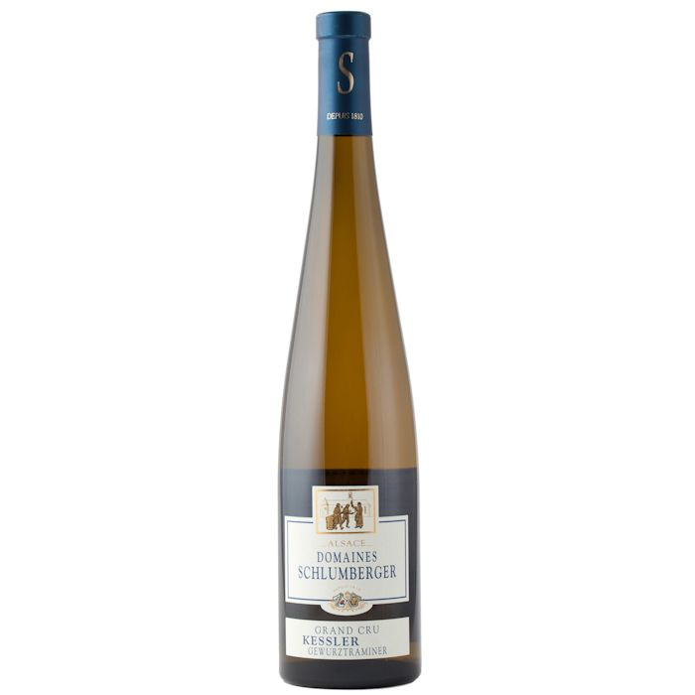

Grape: Riesling.

Region: Alsace.

Tasting notes: The robe is golden yellow with green reflections of good intensity. The nose is marked, pleasant and intense. We perceive a dominant of exotic scents: passion fruit, papaya, citrus fruits (grapefruit, candied orange) and flowers (rose). The airing enhances these scents and reveals mango and spices (candied ginger, white pepper). The onset in the mouth is dense, marrowy and the alcohol support is full bodied. The wine evolves on an incisive medium, marked by a sparkling note. We find the same exotic aromas as on the nose, dominated by papaya, passion fruit, mango, citrus fruits (blood orange, grapefruit), flowers (rose) and spices (white pepper, candied ginger). There is a delicate bitterness. The finish has a long length and a frank and persistent liveliness.

Pairing: This wine can be associated with spicy cuisines: Thai king prawns, a chicken curry with bananas and onions, a soup with hot shrimps and coconut milk or a blue-veined cheese such as the Fourme d’Ambert. Serve at a temperature of 12°C.

£28 per bottle.

2017 Domaine Schlumberger Riesling Alsace Grand Cru 'Saering'
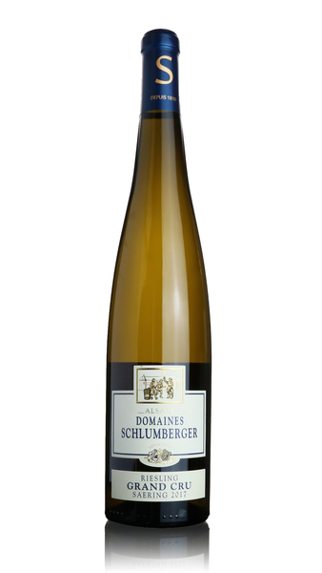

Grape: Riesling

Region: Alsace

Tasting Notes: Lovely fresh, vibrant perfume with a lively floral and citrus character. Fine-grained and dense palate with a pronounced salty-mineral quality lifted by very fine acidity. Finishes bright and with great length indeed, with a beautiful drinkability throughout, a delightful Riesling.

Pairing: Works very well with shellfish and lighter fish dishes.

£29 per bottle.

2019 Chablis Les Lys Premier Cru Domaine Vincent Dampt
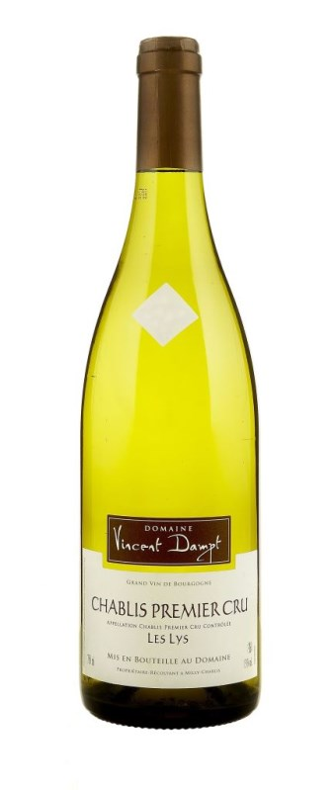
Grape: Chardonnay.

Region: Burgundy.

Tasting notes: Ripe yellow-pear notes rise from the glass and unfold their juiciness on the vivid, ripe palate of this wine. Citrus pithiness adds texture to this generous mouthful while a cool chalkiness helps the freshness along. This wine is wonderfully textured and bright, with a dry finish.

Pairing: Pairs well with pork, rich fish such as tuna or salmon, shellfish & mild or soft cheeses.

£35 per bottle.

2006 Chablis Premier Cru Les Lys Domaine Daniel-Etienne Defaix
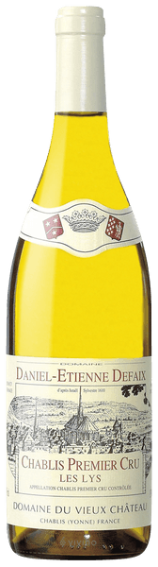
Grape: Chardonnay.

Region: Burgundy.

Tasting notes: This wine has a beautifully evolved and earthy character on the nose with mineral undertones. Great depth and texture on the palate underpinned by bright fresh acidity gives the wine superb length with notes of buttered brioche.

Pairing: Matches seafood well, in particular lobster or pan-fried scallops. This wine also has the power and complexity to pair well with a ripe Epoisses, an archetypal cheese from the region.

£43 per bottle.

2017 E.Guigal Chateauneuf Du Pape Blanc
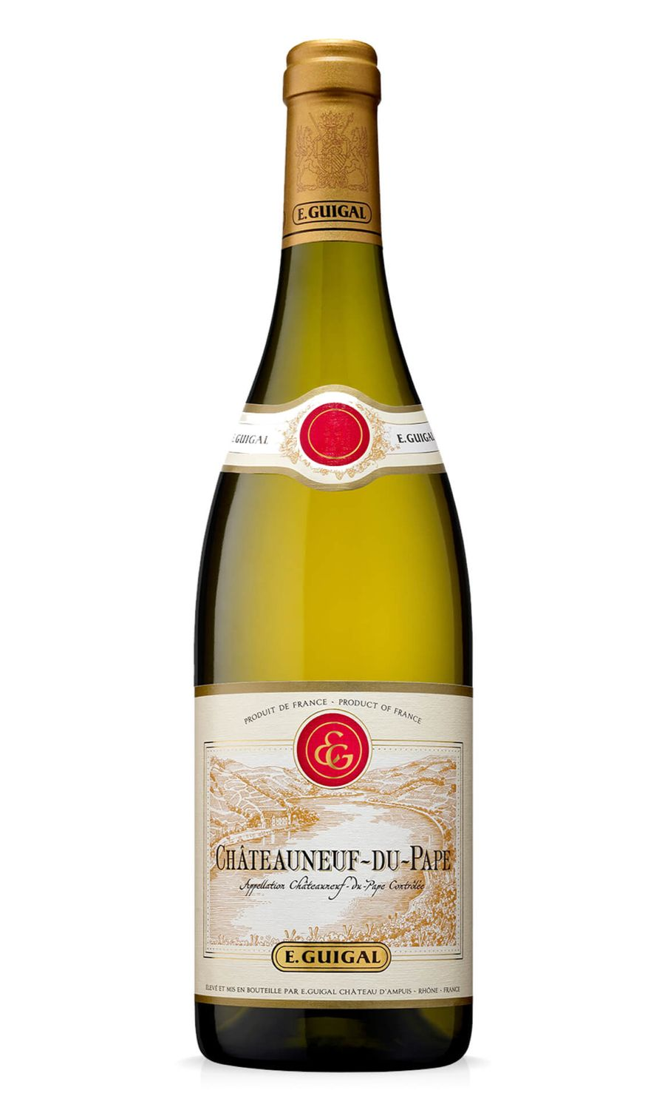
Grape: Grenache.

Region: Rhône.

Tasting notes: Expressive nose of white flowers and peach. An unctuous mouth, balanced and enhanced by a beautiful freshness. Rich and round on the finish.

Pairing: Matches well with rich fish, poultry, pork, cured meats and mature, hard cheeses.

£46 per bottle.

2019 Sauvage Sancerre Blanc Pascal Jolivet
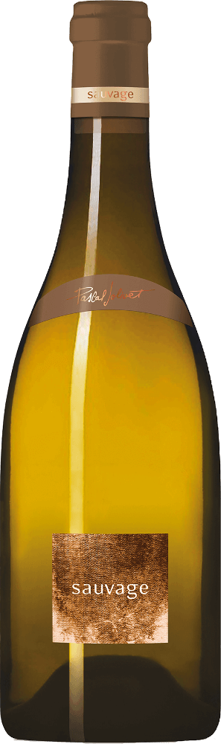
Grape: Sauvignon Blanc.

Region: Loire.

Tasting notes: The Sauvage is elegant and subtle on the nose, medium-bodied and rich on the palate, with layers of mouth-watering fruit leading to a racy finish, while retaining absolute finesse.

Pairing: Excellent with shellfish, rich fish dishes, white meats and poultry.

£47 per bottle
2018 Pouilly Fume, Barre a Mine, Michel Redde
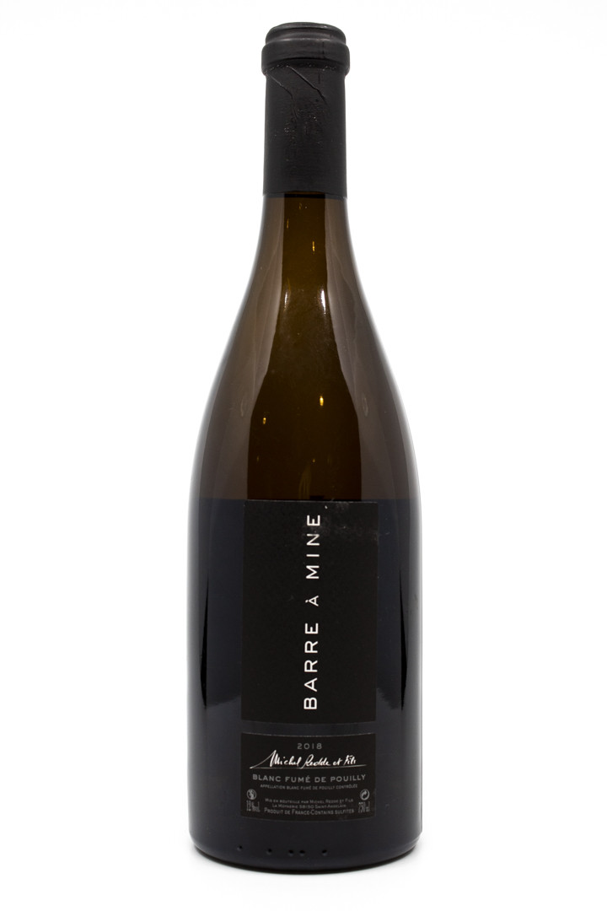

Grape: Sauvignon Blanc.

Region: Loire.

Tasting notes: The nose has notes of exotic pineapple and passion fruit mixed with the flintiness typical of Pouilly-Fume. The palate is full with a spicy, white pepper finish. This wine appreciates decanting to help it reveal its pure minerality, spiciness, salinity and persistence.

Pairing: This wine has excellent pairings with seafood, spicy cuisine and goats cheese.

£57 per bottle.

2017 Condrieu Vidal-Fleury
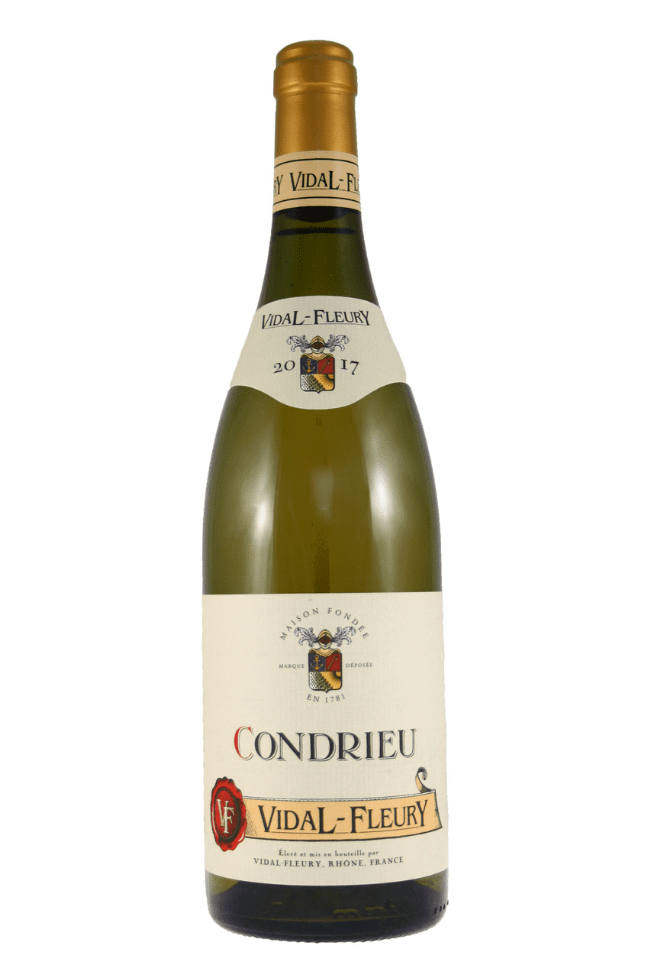
Grape: Viognier.

Region: Rhone Valley.

Tasting notes: Pale yellow colour with flashes of gold. The wine has intense candied citrus, mandarin and lemon aromas with a touch of spicy cinnamon, almond and minerals. Its palate is intense and unctuous with good balanced length and dry apricot, lemongrass and citrus flavours.

Pairing: Pairs well with fish, pork, poultry & hard cheeses.

£57 per bottle.

2018 Chassagne Montrachet, Louis Latour
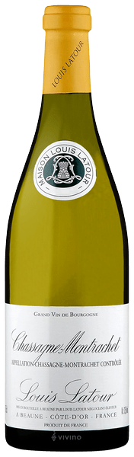
Grape: Chardonnay.

Region: Burgundy.

Tasting notes: This wine is bold, rich and ripe. It has an elegant nose of peach aromas with buttery almond and juicy pear flavours. Attractive aromas of honeysuckle, toasted almonds and white-fleshed fruit can also be found. A wine of restrained power and great finesse.

Pairing: Works well with shellfish such as king prawns as well as charcuterie and goats’ cheese.

£75 per bottle.
2018 Chablis Grand Cru Les Clos Simonnet Febvre
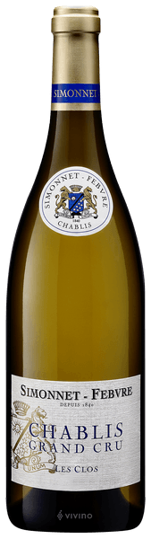
Grape: Chardonnay.

Region: Burgundy.

Tasting notes: A chalkiness on the nose of this wine blends with freshly cut lime zest, creating a vivid mix of aromas. Although the palate tones this down, it still holds immense chalky depth and freshness, despite the vintage's ripeness. The body is generous but lifted, with a hint of lanolin accentuating the richness. This wine will be even more beautiful and chalky with age.

Pairing: Best drunk between 5 and 12 years vintage, it pairs well with pork, salmon, tuna, shellfish and mild or soft cheese.

£77 per bottle.

2018 Puligny-Montrachet Etienne Sauzet
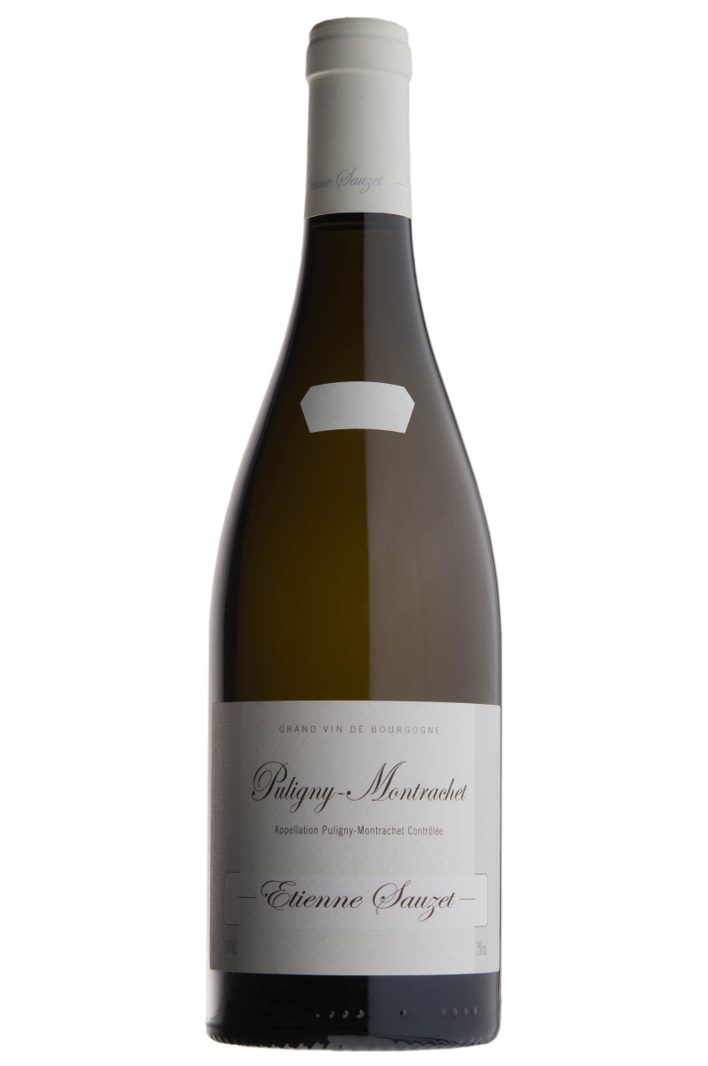
Grape: Chardonnay.

Region: Burgundy.

Tasting notes: A lively bouquet with light scents of yellow fruit and a mineral hint. The wine is very well balanced with a lively acidity, crisp and tight with green apple and a fresh nectarine finish with a nice length. A very finessed, elegant and refined taste.

Pairing: Goes well with sushi, rich fish, pasta and cured meats.

£80 per bottle

2018 Chablis Grand Cru 'Les Blanchots' Domaine Laroche
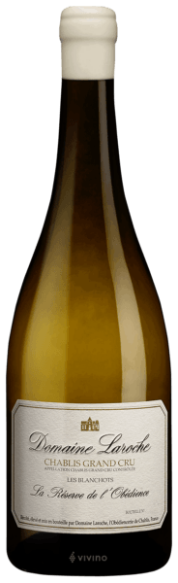
Grape: Chardonnay.

Region: Burgundy.

Tasting notes: Creaminess on the nose of this wine comes with the richness of crème fraiche edged with lemon. A velvety palate enforces this bright, mellow creaminess, layering it with chalky coolness pervaded with zesty lemon. The roundness of 2018 is conserved in refreshing smoothness. Depth is already hinted at on the long, smooth and chalky finish.

Pairing: Excellent as an aperitif, it combines very well with raw ham, dishes based on fish, shellfish, fresh and fat cheeses. Best decanted for around an hour and served between 12 and 14 degrees Celsius.

£85 per bottle.

2020 Chateau de Beaucastel, Chateauneuf-du-Pape Blanc
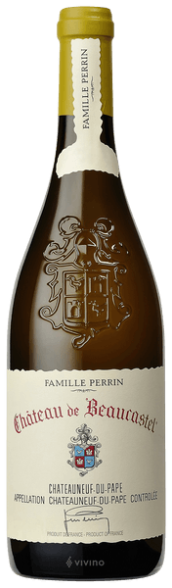
Grape: Roussanne & Grenache Blanc.

Region: Southern Rhone.

Tasting notes: White peach, orange rind, flowers and honey pop on the nose. From there, on the palate you find fresh, bright, juicy apricots, peach, and sweet Mandarin oranges. The wine has flesh and freshness.

Pairing: As a young vintage, this wine would ideally be decanted for 2-3 hours to allow the wine to soften and release its perfume. Best served at 15 degrees Celsius, this versatile wine pairs well with classic meat and seafood dishes whilst also matching well with pasta, mushrooms, cassoulet and Asian cuisine.

£105 per bottle.

2018 Premier Cru La Truffiere, Etienne Sauzet, Puligny-Montrachet
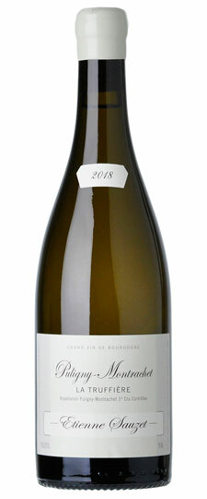
Grape: Chardonnay.

Region: Burgundy.

Tasting notes: A deeply intense wine with white orchard fruit and ginger spice on the nose. The palate delivers lots of concentration and depth with a fine citrus minerality with notes of tangerine. The finish is rich and long.

Pairing: A fairly versatile wine, pairing well with white fish, pasta dishes, shellfish, mild or soft cheeses and cured meats.

£140 per bottle.

2017 Corton Charlemagne, Grand Cru, Latour
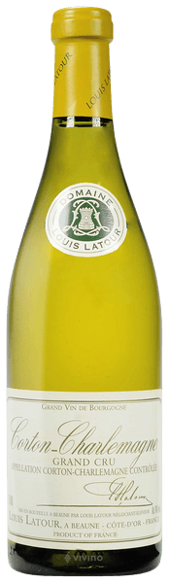
Grape: Chardonnay.

Region: Burgundy.

Tasting notes: This wine has a bouquet rich in lemon aromas with tropical fruits. It is intensely powerful and fills the palate with many flavours that guide us towards a fine, mineral finish that lasts for several minutes.

Pairing: A powerful wine matching well with shellfish, white meat and mushrooms.

£157 per bottle.

2020 Albarino Pazo de Senorans Rias Baixas, Galicia
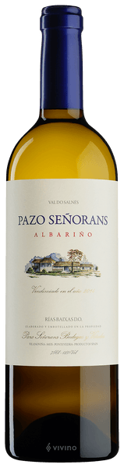
Grape: Albarino.

Region: Galicia.

Tasting notes: Straw yellow colour with some greenish hues. Clean and bright. Great intensity on the nose. Typical aromas of the Albariño variety such as apricot and peach together with floral notes. A fragrant, intensely fruity dry white. No oak treatment is used, the wine is fermented and matured for 4 months in stainless steel. The result is a wine with concentrated and rich pear, peach, honeysuckle and white flower notes balanced with a crisp acidity which leads up to a taut mineral driven finish.

Pairing: Quite delicious all by itself and, naturally, a great paring with seafood. It also goes well with poultry and mushroom based vegetarian dishes.

£20 per bottle.

2011 Albarino Seleccion de Anada Pazo de Senorans
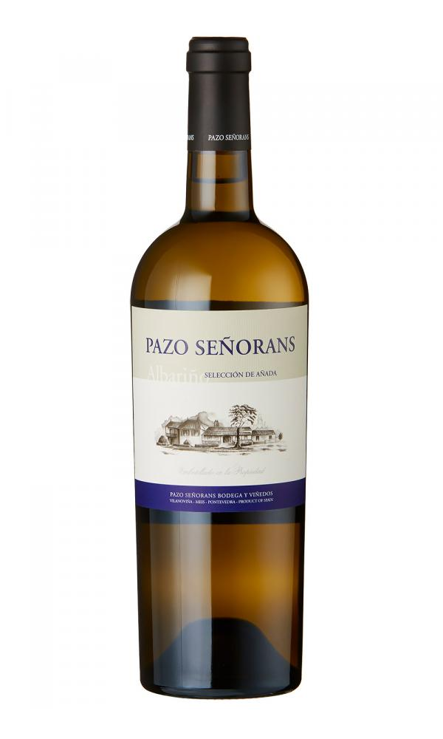
Grape: Albarino.

Region: Galicia.

Tasting notes: There is absolutely no suggestion of oxidation here and, in fact, despite its relative age, this is remarkably vibrant and fresh. On the nose, tropical yet with hints of mineral and also a herbaceous quality. Silky and rounded in texture, it exhibits delicious notes of stone fruit, citrus, fennel, grass, flint and smoke. Exceptional intensity and length.

Pairing: This is a serious and complex Albariño which would be an excellent pairing with almost any seafood.

£55 per bottle.

2020 Lugana Ca de Frati 'l Frati Lombardia, Italy
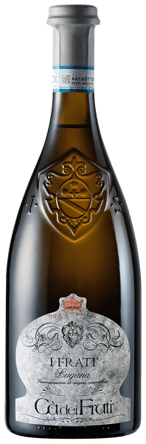
Grape: Turbiana.

Region: Lombardy.

Tasting notes: Light yellow in colour with a concentrated but fresh perfume of white flowers, peaches and ripe lemons. On the palate it has excellent depth and balance, with a lovely, honeyed richness and a crisp, lively finish.

Pairing: This wine pairs well with lukewarm appetisers as well as herbaceous white fish.

£20 per bottle.

2020 Minaia Gavi Del Comune Di Gavi Rovereto
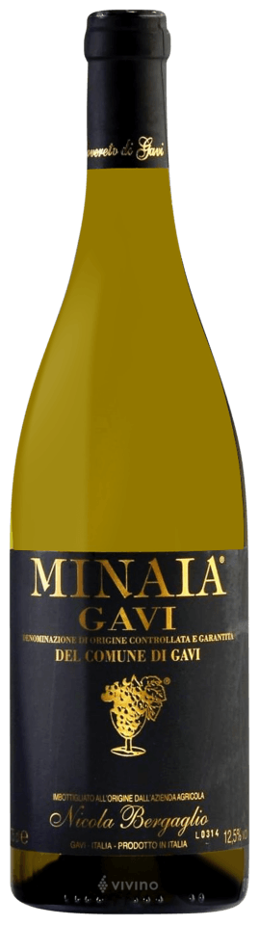
Grape: Cortese.

Region: Piedmont.

Tasting notes: White peach and acacia aromatics, with soft honeyed richness, a cool mineral streak, beautifully balanced and fresh through to long finish. The palate is crisp and dry, with a hint of ripe pears and a complex array of red and green apples, the finish is mouth-wateringly refreshing and lengthy.

Pairing: Matches well with seafood, pasta dishes and cured meats.

£28 per bottle.
2020 Broglia La Meirana Gavi di Gavi
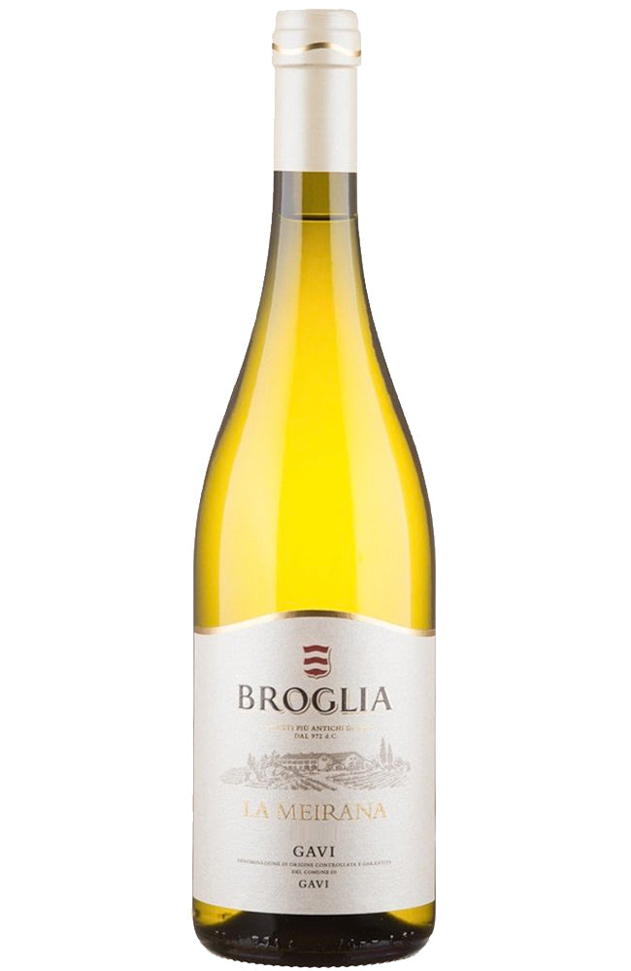
Grape: Cortese.

Region: Piedmont.

Tasting notes: A refreshing white wine that is crisp and clean with crunchy Granny Smith apple, fresh melon, pink grapefruit, peach, fennel, almond and a stony, mineral quality.

Pairing: A perfect partner to summer salads, carpaccio of beef or courgette, minestrone or ravioli drizzled with sage butter.

£30 per bottle.

2019 Soave Classico 'La Rocca' Pieropan, Veneto.
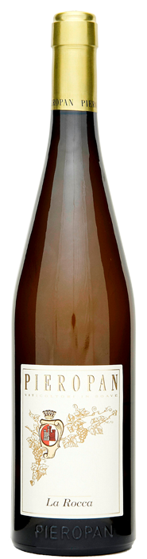
Grape: Garganega.

Region: Veneto.

Tasting notes: Fresh aromas of chamomile, dried pineapple, preserved lemon, toasted almond and beeswax. It’s medium-to full-bodied with tangy acidity, notes of ripe stone fruit, melon and hints of honey combined with the freshness of grapefruits and limes. So concentrated, layered, and phenolic. Keeps going. Yet, it remains agile and vivid.

Pairing: This fresh wine can be enjoyed casually with appetisers but matches well with meals with lean fish and vegetarian dishes.

£35 per bottle.

2019 Cervaro della Salla, Antinori
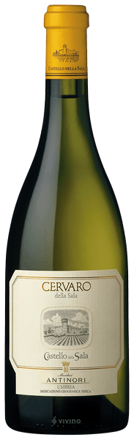

Grape: Chardonnay & Grechetto.

Region: Tuscany.

Tasting notes: The nose of this wine offers notes of chamomile and flint balanced by a hint of vanilla. Full bodied and a well-structured savoury palate of delicate vanilla and butter sensations which transition gracefully into hints of tropical fruit and mineral. It is elegant and persistent in the mouth.

Pairing: A classic Umbrian wine which naturally pairs with classic Umbrian food but is also a particularly good match for guinea fowl and rich chicken and mushroom dishes.

£85 per bottle

2016 Grosses Gewachs Wehlener Sonnenuhr Devon SA Prum GG Mosel
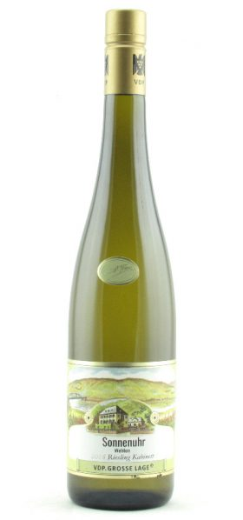
Grape: Riesling.

Region: Mosel.

Tasting notes: It is beautifully fragrant with flavours of peach, apricot, lemon peel and lime with hints of honey. The palate is elegantly structured with pronounced mineral character imparted by the slate-rich soil. Ripe and full-bodied with good acidity underneath.

Pairing: Aged Rieslings are extraordinarily versatile with food. Because of Riesling’s sweetness and acidity, it is especially good with Asian spicy food so a good match would be a spiced Duck Leg. Also goes well with pork and apple-based dishes and for a real treat, pair with an aged goat’s cheese and a sweet chutney.

£37 per bottle.
2016 St Tamas Dry Furmint, Percze, Tokaji, Hungary
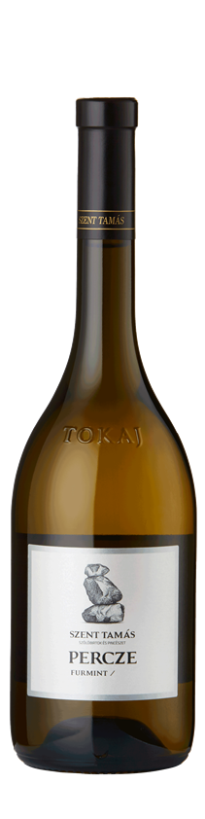
Grape: Furmint.

Region: Tokaj, Hungary.

Tasting notes: Elegant and vibrant medium to full bodied white wine harvested from first class single vineyard Percze. The tasting notes are driven by volcanic minerality, and fruitiness of stone fruits, with citrussy notes. Long, lingering finish. A slightly honeyed nose gives way to a powerful palate combining fresh white fruits, orange peel, enlivening acidity supported by a moreish underlying minerality.

Pairing: A great pairing for pork-based dishes, particularly those containing fennel.

£35 per bottle.

2020 Jordan Stellenbosch Cold Fact
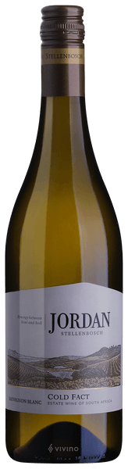

Grape: Sauvignon Blanc.

Region: South Africa.

Tasting notes: Pale, green-tinged in colour. Pungent, mineral-driven aromas of lime zest, gooseberry, flint and fig. Dry, subtle and intense, showing a captivating salinity to its flavours of lime zest, passion fruit and white flowers. Lovely balance, gooseberry freshness on the finish.

Pairing: Match with fish and shellfish dishes as well as goats’ cheese.

£15 per bottle.

2019 Ata Rangi Sauvignon Blanc, Martinborough, NZ
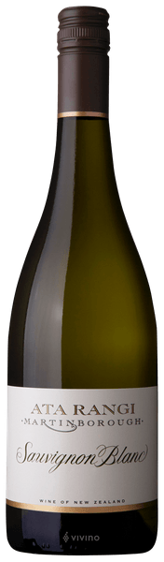
Grape: Sauvignon Blanc

Region: Martinborough, New Zealand.

Tasting notes: Utilising several traditional winemaking techniques including barrel ferments with high solids juice, extended skin contact and partial malolactic fermentation. Around 15% of the fruit was fermented in contact with skins, drawing out their more complex flavours. The grape skins also contain phenolics which, combined with the natural acidity, offer a fresh back bone. These portions are woven together to produce a complex and textural wine. Complex nose of lemon curd, citrus blossom, and white peach with spicy aromatics reminiscent of cinnamon apple pie. The texture that the on-skins and barrel fermentation components bring shows itself in a supple creaminess, which mingles with lemon zest notes and a tangy finish.

Pairing: Pairs well with fresh, herbaceous and summery foods such as salad-based dishes.

£20 per bottle.

2020 Sauvignon Blanc Spitfire "Kim Crawford", Marlborough, NZ
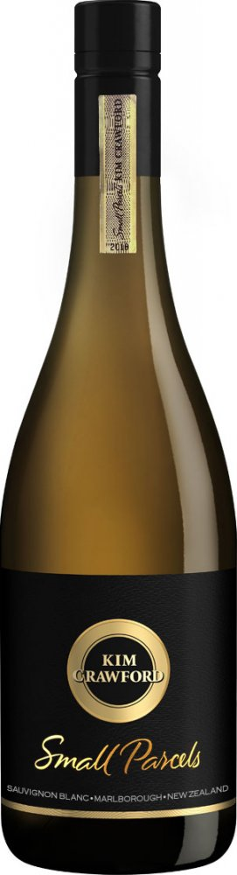

Grape: Sauvignon Blanc

Region: Marlborough, New Zealand

Tasting notes: Intense passion fruit, grapefruit and tropical fruit aromas. Juicy acidity fills the palate on first tasting and activates the taste buds with a gorgeous fruit sweetness that carries through to a long finish.

Pairing: Pairs well with shellfish and vegetarian based dishes, as well as making an excellent accompaniment to goats’ cheese.

£20 per bottle.

2019 Jordan Stellenbosch Nine Yards
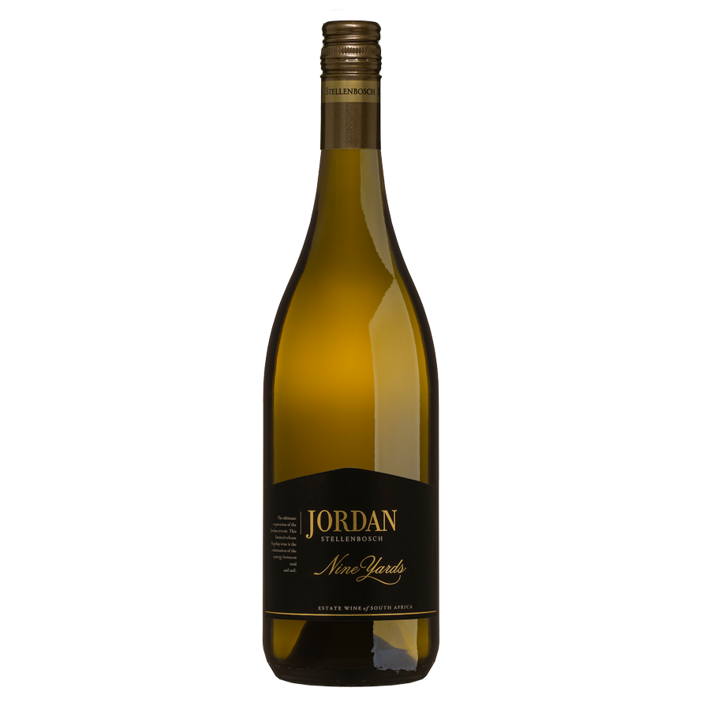

Grape: Chardonnay.

Region: South Africa.

Tasting notes: The nose is very refined with scents of almond, nutmeg, a hint of melted butter but all well-defined and not overpowering. The taste is very well balanced with fresh acidity, a hint of orange peel, pear and peach. French oak integrates with the long, tropical peach and melon finish.

Pairing: Goes excellently with white meats and fish as well as rice dishes.

£29 per bottle.
2018 Greywacke Wild Sauvignon.
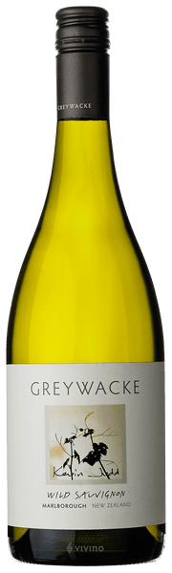

Grape: Sauvignon Blanc

Region: New Zealand

Tasting notes: This Sauvignon Blanc has aromas of candied citrus peel, honeysuckle, brioche, tarragon and lemon thyme. The palate is full with flavours of citrus and stone fruit, with a crisp acidity, a delicate, smoky nuance, and notes of flint on the long, dry finish. An alternative style that is both intricate and textural, with a generous succulent palate and a crisp finish.

Pairing: Matches well with pork and poultry as well as fresh pasta dishes.

£35 per bottle.
2019 Mullineux Quartz Single Terroir, Chenin Blanc, Swartland, S.Africa
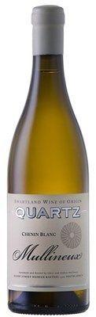
Grape: Chenin Blanc.

Region: South Africa.

Tasting notes: The aromatics are certainly as expressive as the best wines out of the Swartland with clear, defined aromas of crunchy green apples, white pear pastille and a thrilling melange of orange peel and nartjie zest all under pinned by a chain gang dusty crushed rock minerality. The palate is fabulously crystalline and pure with a slightly saline green melon and granny smith apple concentration and a cool, fine focused finish that suggests plenty of textural generosity.

Pairing: Works well with spicy food and the sweet and sour flavours associated with Asian cuisine. Other food it pairs well with include soft cheese, seafood and poultry.

£57 per bottle.
2016 Cakebread Reserve Chardonnay, Napa
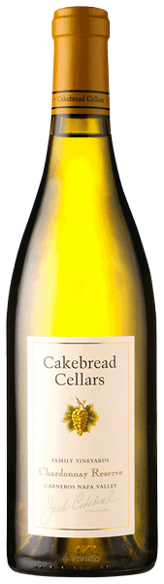
Grape: Chardonnay.

Region: Napa Valley, California.

Tasting notes: Offers slightly floral aromas of creamy golden apple and honeydew melon, with complementary scents of crème brûlée. A full-bodied palate offering intense and expansive melon, peach and apple flavours accentuated by fresh, perfectly balanced acidity. The wine’s long, elegant and focused finish showcases bright, appley flavours with hints of citrus, mineral and oak spice.

Pairing: Pairs well with rich fish dishes, pork, poultry as well as vegetarian meals.

£60 per bottle.

2020 Miraval Côtes de Provence Rose
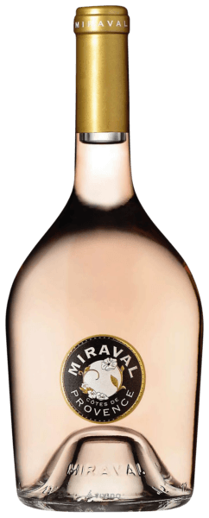

Grape: Syrah, Grenache, Rolle

Region: Côtes De Provence

Tasting notes: Beautiful pale pink colour, intense nose of white flowers, red berries and notes of Morello cherries. Bouquet of great freshness and slight saltiness. Great length with balance between the fruit, minerality and complex aromas of wild herbs, limestone, rich citrus fruit and a long, intense finish.

Pairing: Pairs well with pork, shellfish, vegetarian dishes and poultry.

£23 per bottle.

2020 Whispering Angel Rose
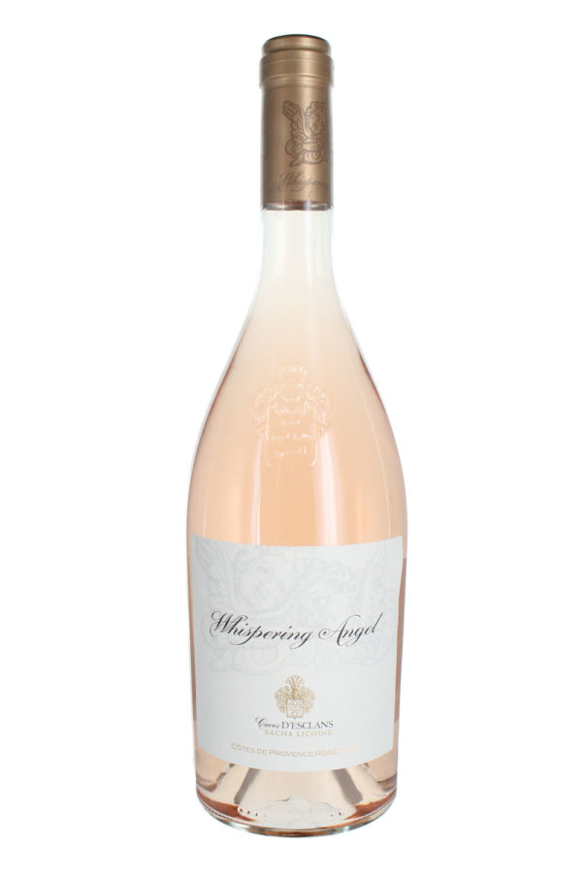
Grape: Grenache, Cinsault & Rolle

Region: Côtes De Provence

Tasting notes: This beautiful salmon-pink Provence rosé has a very pretty scent of crushed strawberries, peach, rose-water and orange blossom. On the palate, it is wonderfully dry and crisp with delicate summer berry fruits balanced by citrus zest acidity and a deliciously creamy finish.

Pairing: A fabulously sophisticated rosé that is perfect for summer picnics or evening aperitif.

£23 per bottle.

2019 Rosé Côtes de Provence Le Grand Cros Cuvée Aurélia
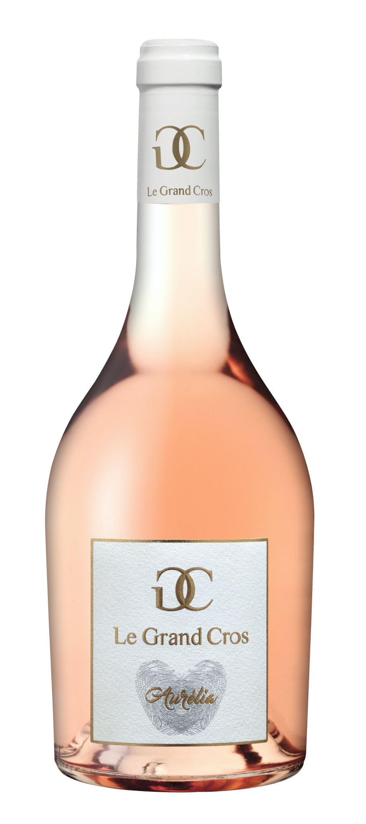
Grape: Mourvèdre, Grenach and Syrah

Region: Côtes De Provence

Tasting notes: Elegant pink hue with salmon reflections. The nose is expressive and complex with a floral touch (broom), notes of candied fruit (melon, mango), sweet spices (cinnamon). The palate is ripe, full with a touch of freshness on the attack (grapefruit), there are candied fruit and it ends with notes of sweet almonds. A beautiful structure reinforces the original and elegant character of this gastronomic rosé.

Pairing: Pair with fish-based main dishes, fish-based pasta or rice dishes, vegetarian dishes.

£27 per bottle.

2020 Domaine Ott, Clos Mireille, Côtes de Provence Rosé
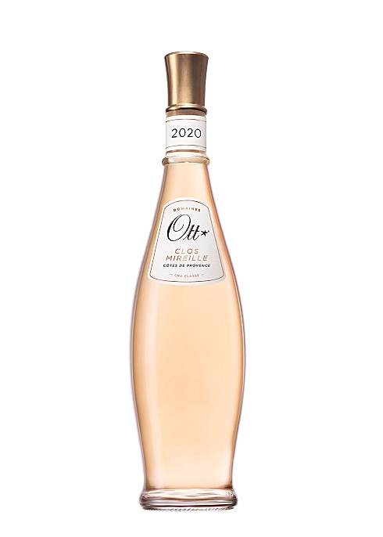

Grape: Grenache Noir, Cinsault, Rolle & Syrah.

Region: Côtes De Provence.

Tasting notes: The wine is a very pale pink highlighted, depending on the vintage, with golden, orange and even vermilion tints. Its bouquet reveals fresh fruit (mango, melon) punctuated with lemony notes. On the palate, its freshness develops through citrus aromas around a resolutely mineral core before ending with a subtly persistent finish.

Pairing: Pairs well with both white and red meat (mainly lamb) as well as mushrooms and herbaceous, peppery dishes.

£39 per bottle.

2018 Chateauneuf-du-pape Haute Pierre Delas
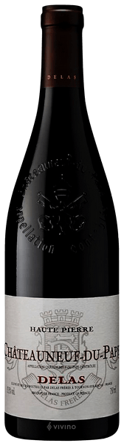
Grape: Grenache & Syrah.

Region: Rhone Valley.

Tasting notes: A lovely deep garnet red robe. To the nose, the "Haute Pierre" cuvée is characterised by strong spicy aromas. The palate conveys a rich, powerful body wrapped around with a more delicate yet tightly knit tannic framework. Rich and unctuous on the texture, the finish reveals some intense, liquorice like flavours.

Pairing: This rich wine pairs well with red meats, stew-based dishes and veal ragout. Recommended serving temperature of 14-16 degrees.

£46 per bottle.
2012 Gevrey Chambertin Charles Audoin
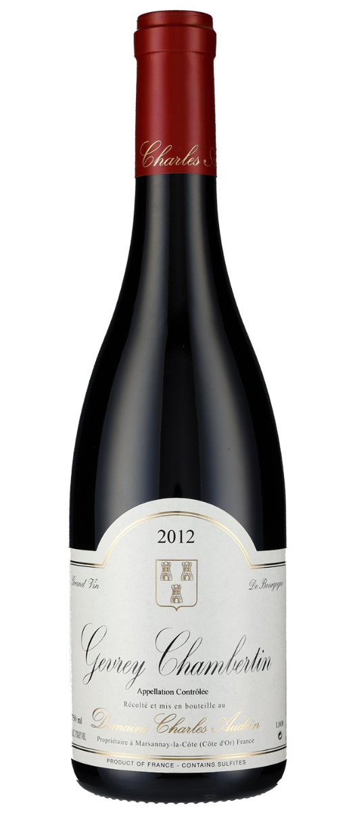
Grape: Pinot Noir

Region: Burgundy

Tasting notes: Elegant and spicy pinot on the nose, following up on the palate with impressive balance – fresh and juicy fruit but with a firmness and good structure. Finishes well, with an interesting dark fruit and herbal quality.

Pairing: Matches well with rich, gamey dishes as well as beef and veal.

£46 per bottle.

2018 Domaine Tollot Beaut Savigny-Les-Beaune 1er Cru Les Lavieres
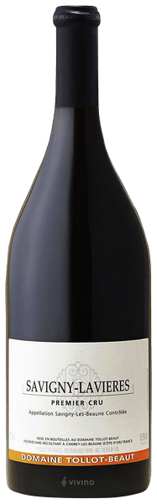

Grape: Pinot noir.

Region: Burgundy.

Tasting notes: Velouté, rich curvaceous fruit wrapped in glossy, noble tannins. Broad but charming. Sensual damson and strawberry fruit gently covers the palate. Seductive, elegant Savigny. The soils of Lavières are shallow and sandy resulting in supple, elegant wines that are often very expressive in their youth.

Pairing: Pairs exceptionally well with duck, goose & game birds as well as larger game such as venison.

£50 per bottle.
2018 Volnay Domaine Georges Glantenay Cote de Beaunes
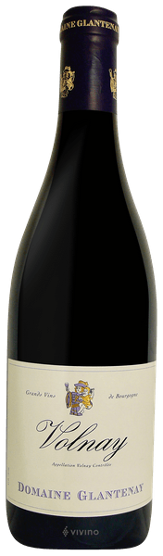
Grape: Pinot Noir.

Region: Burgundy.

Tasting notes: This Volnay is an intense garnet colour. The nose has concentrated aromas of red fruits. The palate is rich and elegant with floral notes of violet and blackcurrant with flavours of cooked fruits and liquorice appearing as it ages. Velvet tannins rounds out the fresh acidity.

Pairing: Pairing well with large game such as venison and red meats like beef and veal.

£50 per bottle.

2018 Cote Rotie La Sarrasine Domainede Bonserine
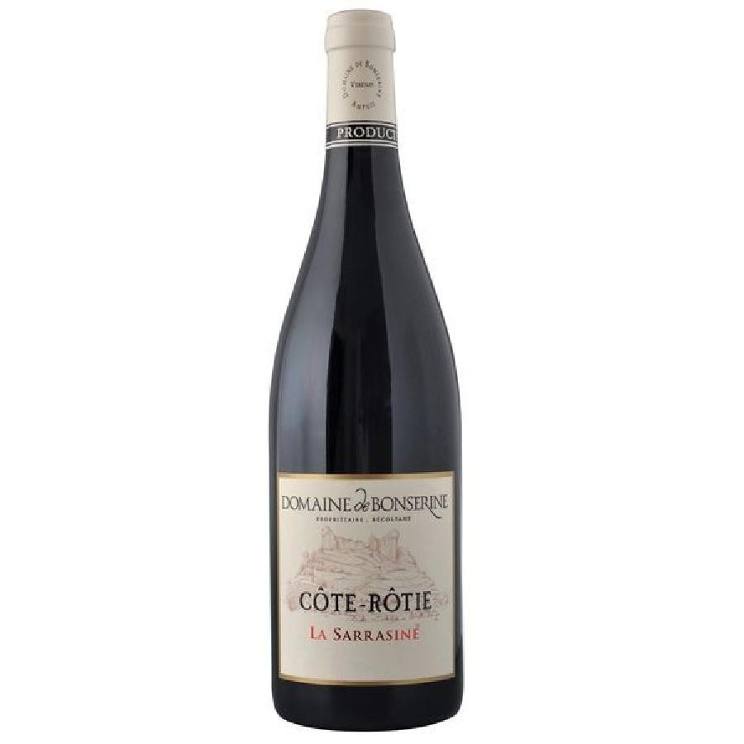
Grape: Syrah & Viognier.

Region: Rhone Valley.

Tasting notes: A sustained, deep ruby colouration. The nose combines violets and roses with black fruits and a finely roasted, chocolatey base. The palate is earthy and meaty, opulent and has great finesse. Notes similar to the nose, with pronounced violets and dark cherries with crunchy, fine tannins and green pepper. A long, perfectly channelled, powerful finish.

Pairing: Best served at 16 degrees, pairs well with grilled red meat and small game birds. Is a great accompaniment for a variety of strong cheeses.

£54 per bottle.

2015 Chateau La Grave Pomerol
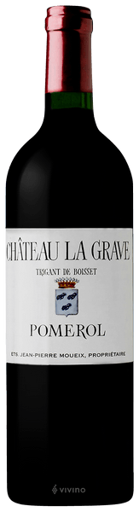

Grape: Merlot & Cabernet Franc.

Region: Bordeaux.

Tasting notes: Dark purple red colour with a violet hue. Elegant nose with pure fruit, discreet spiciness and hints of minerality. On the palate, elegant but persistent character bursting with fine fruits. Finishes firm with a rich, lengthy finish and a discreet spiciness in the aftertaste.

Pairing: A wine that lends itself to a dinner party with friends, it pairs well with cured meats and nutty or smoked cheeses.

£55 per bottle.
2006 Chateau Kirwan, Margaux
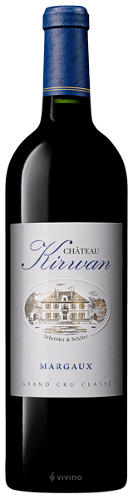
Grape: Cabernet Sauvignon.

Region: Bordeaux.

Tasting notes: Quite fragrant, silky and floral, with plenty of cherry and violet aromas. The palate has lovely creamy sweetness. There's plush fruit here, with a creamy, quite plummy fullness, and though tannins are dry and quite prominent, this has a chocolaty depth and good acidity.

Pairing: Pair with roasted lamb, braised veal, rib of beef with bones and pan-seared mushrooms or cheeses such as tommes or gouda.

£68 per bottle.

2008 Chateau Lynch Bages, Pauillac
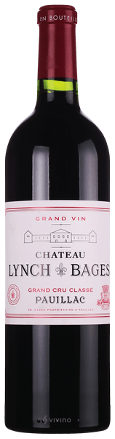

Grape: Cabernet Sauvignon, Merlot, Cabernet Franc & Petit Verdot.

Region: Bordeaux.

Tasting notes: Dark ruby ​​garnet, violet reflections, delicate brightening of the edges. On the nose rather restrained, delicate herbal spices, blackberry jam, nougat, a hint of orange zest. Medium complexity, red berry jam, present, somewhat angular tannins, remains dry in the finish.

Pairing: Pair with rich red meat and large game such as venison.

£150 per bottle.

2012 Chateau Chauvin Saint-Emilion Grand Cru
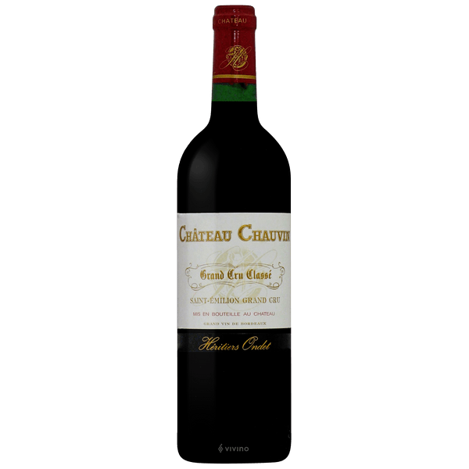

Grape: 75% Merlot, 20% Cabernet Franc and 5% Cabernet Sauvignon.

Region: Bordeaux.

Tasting notes: The bouquet oscillates between notes of blackberries, cherries and blackcurrant and then evolves into aromas of leather and cigars. In the mouth, we find all the nobility that the nose could suggest. The tannins are rich and persistent as is the finish.

Pairing: Goes well with rich meaty dishes with beef, lamb and venison.

£175 per bottle.
1981 Chateau Margaux 1er Cru Grand Classe Margaux
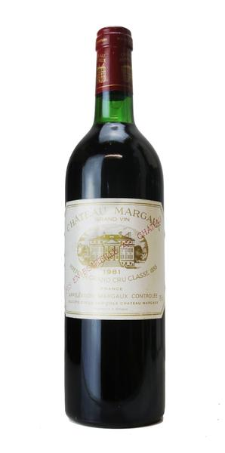
Grape: Cabernet Sauvignon, Merlot & Petit Verdot.

Region: Bordeaux.

Tasting notes: The bouquet is fine, distinguished, elegant and classic. The wine is balanced on the palate and the finish shows tenderness, softness and superb length. In weight and texture, the 1981 Margaux is closest in style to the 1979. It is an outstanding wine, even in the company of the monumental wines of 1982, 1983, and 1986, although it does not have the power and weight of these vintages. It is still very dark ruby/purple-coloured. The aromatics suggest ripe cassis fruit, spicy vanillin oakiness, and violets. On the palate, the wine is medium-bodied, concentrated, tannic, and extremely long. It is just beginning to open and evolve.

Pairing: Chateau Margaux offers its best drinking and should reach peak maturity between 18 and 60 years of age after the vintage. Therefore, as of 2021, this wine is just reached into its best years at 40 years old. Chateau Margaux is best served at 15.5 degrees Celsius. The cool, almost cellar temperature gives the wine more freshness and lift. It is best paired with all types of classic meat dishes, veal, pork, beef, lamb, duck, game, roast chicken, roasted, braised and grilled dishes. Chateau Margaux is also good when matched with Asian dishes, rich fish courses like tuna, mushrooms and pasta.
£700 per bottle.
2016 Rioja Luis Canas Reserva Seleccion de la Familia
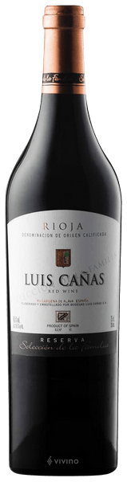

Grape: Tempranillo.

Region: Rioja.

Tasting notes: A beautiful ruby colour. A clean nose with good intensity. Complex aromas of leather, ripe sweet fruit and herbs over a base of fine oak. Palate: Potent and juicy with structure and good tenacity. The finish shows lots of spice and is ample, complex, long and persistent.

Pairing: Best served with pasta dishes, roasted lamb and beef, stews and poultry.

£28 per bottle.
2014 Gran Reserva Rioja Marques de Murrieta
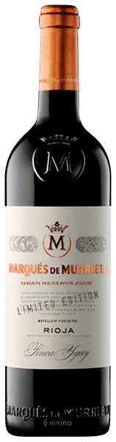

Grape: Tempranillo.

Region: Rioja.

Tasting notes: Dark intense red colour with a mature aroma of mellow red and dark fruits with hint of spicy oak. Full bodied and generous fruit softening as it matures. Lovely finish full of spicy fruit as it starts to soften and mature.

Pairing: Decant for at least half an hour before serving at 16-18 degrees, pairs well with all kinds of red meats, bellota ham, grilled fish and dishes with rich sauces.

£52 per bottle.

2015 Rioja Reserva 'Culmen' Bodgas Lan
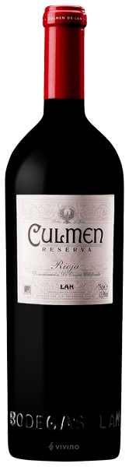

Grape: Tempranillo & Graciano.

Region: Rioja.

Tasting notes: This wine has an intense and bright cherry-red colour. Elegant and layered on the nose, with a bouquet that combines ripe-red fruit, blackberries, pastry as well as fennel and liquorice notes. Smoked wood, nutmeg and cinnamon spices from oak ageing add complexity to the wine. Its deep earthy and mineral notes are characteristic of all the wines made from grapes sourced from the Viña Lanciano estate. This wine is structured, powerful and full bodied with a long and persistent finish.

Pairing: Pairs well with Stews, Mature cheese, Roasts, Game birds and Poultry.

£70 per bottle.

2016 Villa Antinori Chianti Classico Riserva
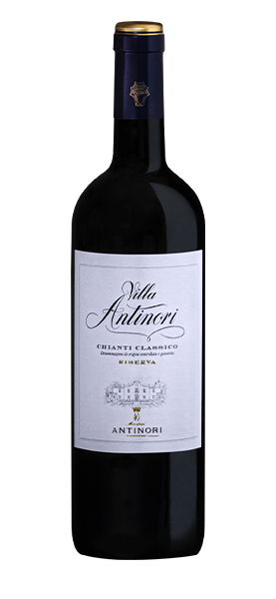
Grape: Sangiovese

Region: Tuscany

Tasting notes: This is tight on the palate with cherries and berries and hints of toasted oak and cedar. It’s medium-bodied and compact, with fine tannins and a fresh finish. Lovely fruit notes at the end.

Pairing: Matches well with beef, veal and poultry dishes.

£40 per bottle
2016 Tommassi, Ca/Florian, Amarone della Valpolicella, Classico
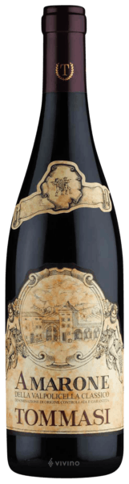

Grape: Corvina Veronese, Rondinella, Corvinone & Oseleta.

Region: Tuscany.

Tasting notes: Deep red with purple reflections. The bouquet is reminiscent of juicy cherries, dried fruit, sultanas, cooked prunes and wild herbs, but also white pepper, mocha and liquorice. Full, complex and velvety on the palate, fine and round, with soft tannins and long persistence.

Pairing: Pairs well with aged cheeses, red meat and game. Excellent accompaniment to hare with herbs.

£49 per bottle

2017 Felsina Beradegna 'Rancia' Chianti Classico Riserva
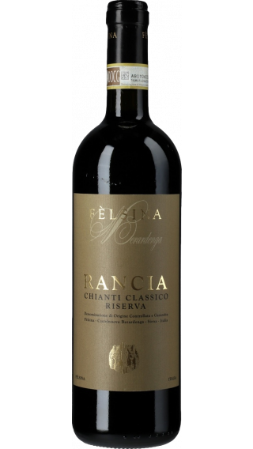

Grape: Sangiovese.

Region: Tuscany.

Tasting notes: Deep ruby red in colour with a spicy nose with floral and wild berry notes. Great elegance and finesse on the palate with a fine mineral note. It is opulent with ripe berry characters and a long, spicy finish.

Pairing: Rancia at this age is great with guinea fowl, pheasant or with a slow-roast (shoulder of lamb or pork).

£59 per bottle.

2017 Amarone della Valpolicella Classico Allegrini
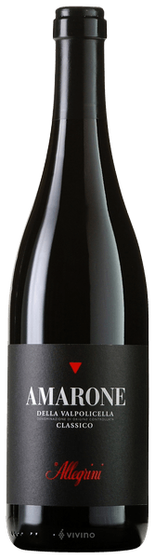

Grape: Corvina, Rondinella & Oseleta.

Region: Tuscany.

Tasting notes: Ruby sloping down on inked shades. Olfactory emanation calibrated on warm notes of withered violets, both ripe and confitured blackberries, sweet spices and tomato confit that converge towards darker aromas of wet fur, willow bark, Tuscan cigar, cocoa beans and resin. The taste reveals a broad and robust structure that does not yield a millimetre in elegance and clarity; the various components appear merged into each other to compose a precious harmony culminating in a mineral, clear and tenacious finish.

Pairing: Traditionally enjoyed with game, roasted and grilled meats, casseroles and well matured cheeses. Excellent with hearty dishes. Amarone’s distinctive flavour compliments exotic sweet and sour cuisine and is therefore also perfect with Asian and middle eastern dishes.

£75 per bottle.

2014 Barolo 'Parafada' Massolino
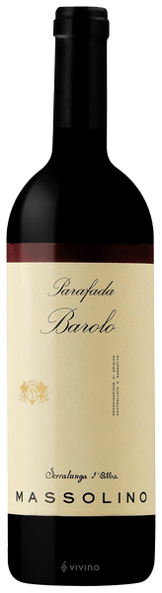

Grape: Nebbiolo.

Region: Piemonte.

Tasting notes: This gorgeous red opens with classic aromas of forest floor, wild berry, crushed herb, blue flower and a whiff of menthol. It's all about structure and finesse, delivering succulent Marasca cherry, raspberry compote, liquorice, baking spice and crushed mint flavours. Bright acidity and firm, polished tannins give it wonderful balance and a smooth texture.

Pairing: A classic and savoury wine, pairs best with rich lamb dishes.

£76
2017 Cepparello Isole e Olena
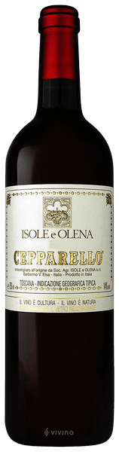

Grape: Sangiovese.

Region: Tuscany.

Tasting notes: The wine is dense and vibrant ruby red. It has a subtle finesse that exudes pure black fruit, minerals, and liquorice notes. It is refined and elegant with a clear tannic grip. Cepparello has a long aging potential, so it's perfect for the cellar.

Pairing: Ideal in combination with second courses based on game, beef stew, roasted wild boar and seasoned pecorino.

£86 per bottle.
2018 Jordan Stellenbosch Black Magic
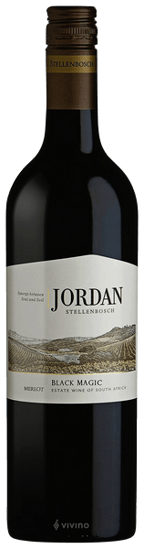

Grape: Merlot.

Region: South Africa.

Tasting notes: The nose is hit with smooth aromas of fruit, leather & spice. The palate opens up to reveal a full body with sweet plum, blackcurrant, green herbs and a hint of oak spice. The tannins are soft and well-integrated.

Pairing: Pairs well with rich fillets of meat such as lamb cutlets, steak and venison chop.

£18 per bottle.

2018 Jordan Stellenbosch ‘The Long Fuse’
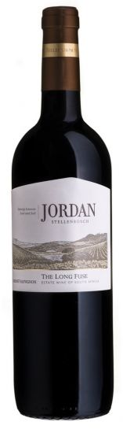
Grape: Cabernet Sauvignon

Region: South Africa

Tasting notes: Deep ruby colour. Aromas typical of the variety & terroir - cedar, bramble and toasted tobacco. The palate has wonderful mouth-filling flavours of blackberry, cassis and vanilla. French oak barrels add a complex toastiness. Alluring in its youth but will reward those who cellar the wine. Full flavoured with dark fruits and spice.

Pairing: Matches well with red meats, game and hard cheeses.

£20 per bottle
2018 Malbec Vina Cobos Bramare Lujan de Cuyo
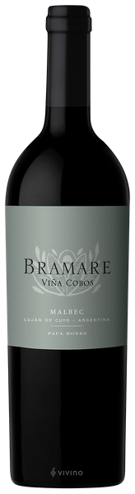
Grape: Malbec.

Region: Mendoza, Argentina.

Tasting notes: A wine with aromas of ripe red and black fruit mixed with spicy notes of vanilla, clove, cinnamon and cigar box. It's complex, long and structured wine with broad, firm tannins and rounds off with a long and satisfying red fruit finish.

Pairing: A simply succulent wine that would partner similarly succulent meat, something along the lines of a slow roast leg of lamb.

£33 per bottle.

2017 John Duval 'Plexus', Barossa Valley
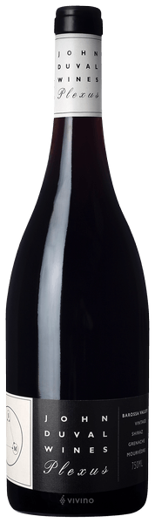

Grape: Grenache, Mourverde & Shiraz.

Region: Australia.

Tasting notes: This wine is vibrant purple-red in colour with intense aromas of red berries, rose petals and dried herbs which are complimented by cinnamon and earthy notes. It is medium bodied with concentrated flavours of raspberry, redcurrant and black plum. Soft texture comes from supple tannins and bright acidity.

Pairing: Pairs well with barbeque dishes and red meats.

£33 per bottle.

2015 Peter Lehmann Stonewell Shiraz, Barossa Valley
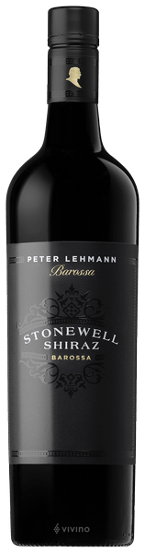

Grape: Shiraz.

Region: Australia.

Tasting notes: This wine has a crimson rim with a deep black core. Black fruited with ironstone and fig with a spice and char with some nice cedar undertones. It has a textural palate with intense red and dark plummy fruits. More dark chocolate in style, the tannins are just starting to open up to reveal a wine of immense power and grace.

Pairing: Pairs well with any red meat, gamey dishes and poultry.

£40 per bottle

2019 Galpin Peak Pinot Noir, Bouchard Finlayson, Walker Bay, Western Cape, S.A.
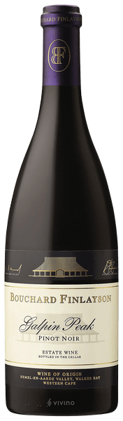
Grape: Pinot Noir.

Region: Western Cape, South Africa.

Tasting notes: Firm and resonating with anticipation, its flavour profile is slowly unfolding where a little patience will offer a generous palate of fruits of the forest flavours and development of complex cherry and dark berry tones. Polished and lingering, it will benefit from ageing.

Pairing: Pinot Noir always expresses itself best with good food. Avoid any sweetness or too much spice. Enjoy with Emmental cheese, salmon, duck or beef.

£47 per bottle.
2018 Altos Las Hormigas Malbec 'Appellation Gualtallary', Uco Vally

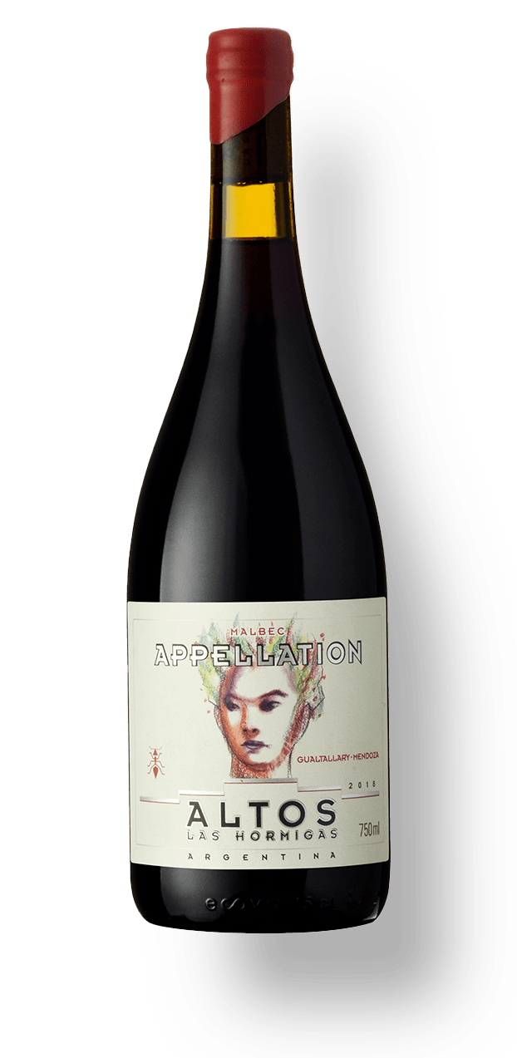
Grape: Malbec.

Region: Mendoza: Argentina.

Tasting notes: Fresh red fruit notes, cranberries and wild strawberries are followed by layers of spice and herbs. On the palate, fruit is intensely concentrated intensifying through the mid-palate to the finish. The limestone tannins and calcareous soils build a firm but balanced structure in the mouth, with elegant minerality and a long finish.

Pairing: This wine is bold and structured, and therefore pairs well to beef and venison dishes.

£49 per bottle.
2013 Viu1, Malbec, Viu Manent, San Carlos vineyard, Colchagua Valley
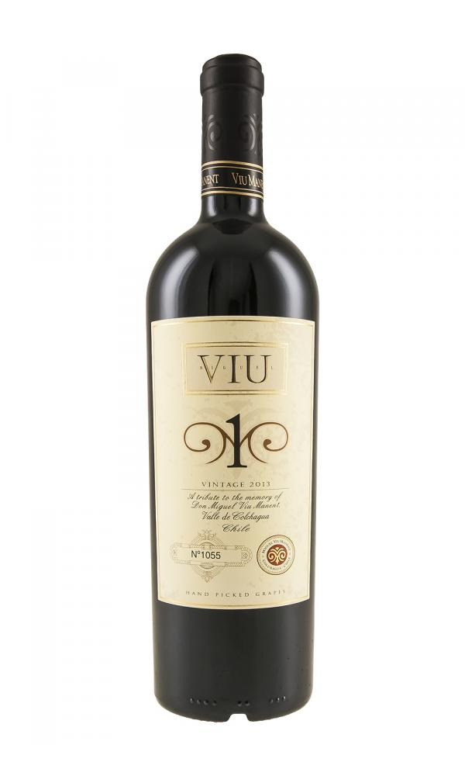
Grape: Malbec.

Region: Colchagua, Chile.

Tasting notes: Deep violet, almost black in colour. The complex and elegant nose recalls plums, violets, forest fruits, sweet spices, and cigar box. The flavourful palate is fresh and profound with tremendous structure, smooth texture and good balance between tannins and acidity.

Pairing: Casseroles and robust meat dishes are great with this wine.

£66 per bottle.
2016 Charles Melton Nine Popes, Barossa Valley
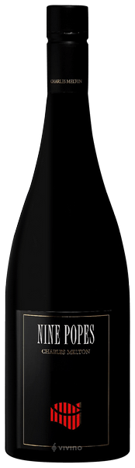

Grape: Grenache, Mataro & Shiraz.

Region: Australia.

Tasting notes: Medium deep colour, the bouquet is a lovely amalgam of cedar oak with softly sweet Grenache perfumes and some liquorice spice in the background. Elegantly defined palate with a fine balance between weight and strength., Plump mid palate with soft tannins. Some savoury grip to finish. Will richen in both perfume and body over the next decade.

Pairing: This full-bodied shiraz lends itself to rich beef and venison dishes.

£69 per bottle.

2018 Ata Rangi Pinot Noir, Marinborough, NZ
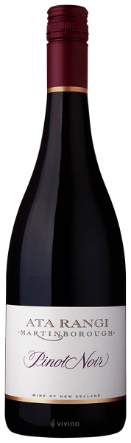
Grape: Pinot noir.

Region: Martinborough, New Zealand.

Tasting notes: Aromatically this wine offers layers of flavours: violets, dark cherry and plum, notes of dark chocolate and tobacco with a faint whiff of gamey notes. Fresh, vibrancy on the palate with smooth tannins pulling the wine through to a long, salivating finish.

Pairing: Pairs well with rich, red meat dishes. In particular lamb, where a herby rack of lamb presents itself as a wonderful accompaniment.

£70 per bottle.

2017 Moss Wood Cabernet Sauvignon, Margaret River.
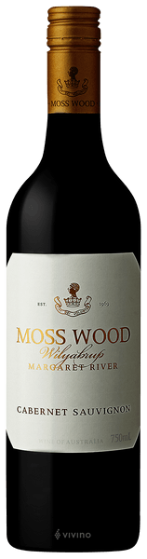

Grape: Cabernet Sauvignon, Cabernet Franc & Petit Verdot.

Region: Australia.

Tasting notes: A classic Cabernet combination of blueberries, violets, blackberries with tar and cedar notes. In the traditional Moss Wood style, the first impression here is one of bright, generous blue and black fruit flavours, sitting over concentrated but balanced tannin. It’s the classic vineyard statement. However, there are also some pointers to the 2017 season, with crisp acidity, giving the palate a taut, almost zippy feel. The finish is firm, with a very light touch of toasty oak, mixing with cedar and tar.

Pairing: Pairs well with beef, lamb and poultry dishes.

£70 per bottle.
2018 Littorai 'Les Larmes' Anderson Valley, California
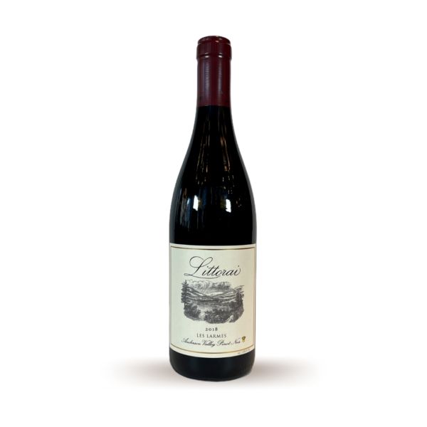Grape: Pinot noir.

Region: California.

Tasting notes: Seductive dark cherry & blackberry on the nose followed by spice box notes. A supple silky body with heady fruit and a lovely lift keep things fresh. Very long and endlessly deep.

Pairing: Enough weight to hold up to the richness of the duck but brightness to balance it, the fruit and spice notes of this wine will complement the flavours of the duck and echo sweetness of the braised cabbage.

£72 per bottle.
2013 Robert Mondavi Cabernet Sauvignon Reserve.
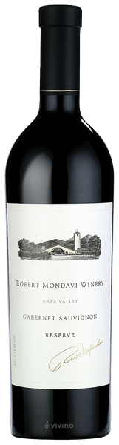

Grape: Cabernet Franc, Cabernet Sauvignon, Petit Verdot.

Region: Napa, California.

Tasting notes: A beautifully polished wine, with a dense ruby/purple colour, it is still tightly knit and showing high-quality oak. The wine is full-bodied and rich, with outstanding depth, ripeness and purity. There is plenty of backbone and tannin for 25-30 years of cellaring. The wine shows notes of chocolate and plenty of blackcurrant fruit and blackberry.

Pairing: Ideally decanted for 2 hours, this wine is excellent when enjoyed with filet mignon and other steak cuts.

£200 per bottle

2011 Chateau Rieussec, Premier Grand Cru, Sauternes
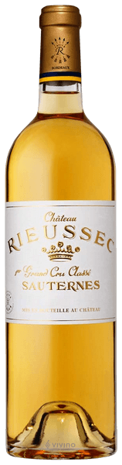

Grape: Sauvignon Blanc & Semillon.

Region: Bordeaux.

Tasting notes: The bouquet is more opulent than some, with classic aromas of ripe stone fruit allied to a honied richness, while the palate has a creamy texture and lovely complexity and intensity. The finish is long and balanced, and the overall impression is of a deeply rewarding wine. Still, one can feel a great sense of freshness.

£45 per bottle.

1997 Chateau d'Yquem, Sauternes
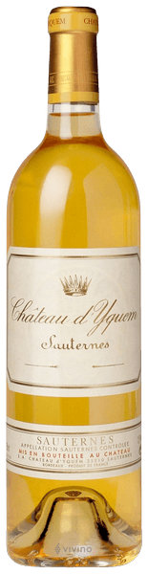

Grape: Sauvignon Blanc & Semillon.

Region: Bordeaux.

Tasting notes: Yquem delivers an aristocratic, dizzying complexity. It's jam-packed with nuance and an almost overwhelming impact. The breadth and depth of Yquem is insane. The 1997 shows its nobility in a profoundly deep and enveloping sort of way. It has ultra-clear honeyed notes that are animated by citrus and further complicated by smoke, flowers, spice and an elusive nuttiness that ranges from marzipan to hazelnuts. The lifespan is as shocking as the wine itself. There's an abundance of stories of Yquems that have seen their 100th birthday.

£175 per bottle.

2018 Mylitta Late Harvest, Tokaj
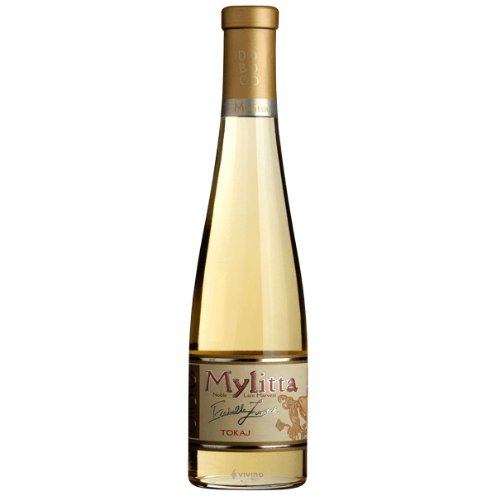
Grape: Furmint, Harslevelu, Muscat.

Region: Tokaj.

Tasting notes: Aromas of blossom and honey, accompanied by refreshing citrus notes. The palate is deeper and more complex. A myriad of different apricot varieties and flowers. Marked by a wonderful, crystal-clear structure and exemplary balanced finish.

Pairing: An excellent match for creamy desserts such as crème brûlée.

£25 per bottle

2017 Vin de Constance, Klein Constantia, Groot, Constantia
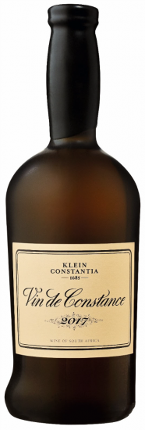

Grape: Muscat.

Region: Constantia, South Africa.

Tasting notes: Bright, golden colour with a deep and enticing nose of white flowers, orange blossom, ripe peach, apricots and honey; notes of white almonds, ginger and nutmeg, add a nutty, spicy feel lifting the general aromatic profile. On the palate the wine has a remarkable presence and elegance, a velvety texture with excellent balance of alcohol, sugar and zesty acidity that will allow the wine to age for decades if not generations. Everything is in place filled with flavours of nectarines, apricot, tangerine, soft yellow plum and honeyed almonds, a real delight that lingers on the mouth while invites to the next sip of joy.

£55 per bottle

